AH 60
DLA 3: Organizing & Learning Medical Information Effectively

If at any time, you have questions about how to complete any part of this DLA,
email them to: mdsc@lbcc.edu

After completing this activity, students will be able to:
- organize information learned from lectures and reading assignments
- better prepare for upcoming exams

Warm Up:
1.) When learning a large amount of information, such as the components of the Digestive System or several vocabulary words, how do you normally take on such tasks?

2.) When preparing for a quiz or exam, what are your study habits normally like?

3.) How effective are your current learning techniques and study habits? How do you know?

Introduction:
Throughout your program, you will be required to learn a lot of very important information such as medical terms, human body systems, and the process for identifying diseases. Not only is your current role as a student important, but you are also learning how to become an effective health care provider in the future. For many of us, learning a large amount of information in a short period of time can be difficult. At various points in each semester, you will be required to demonstrate your understanding of what you have learned. What can you do in order to really absorb what you write in your notes and while you read? How can a medical assistant student recall all of this information?

Graphic Organizers:
Close your eyes and imagine walking into a grocery store to buy some milk. Where do you go? If you see the cereal section, would you go there because people pour milk into their bowls of cereal? Or maybe to the soda section because milk is a beverage? While those sections might make a little bit of sense, we all know milk is located in the refrigerated dairy section. Stores organize their products into departments so that customers are easily able to find the items they are shopping for. Similarly, in learning new information, it is easier if we organize and compartmentalize information so that when we need to retrieve that information, say on a homework assignment or an exam, we will be better able to access that information.
How can you organize information from lectures or reading assignments so you are able to study more effectively? A graphic organizer is an excellent tool for this exact task. Graphic organizers allow us to take the information that we are learning about and place them into specific categories that we have already prepared in a chart, diagram, or organizational map. They allow us to see relationships, compare and contrast information, and see how systems work.

Using the following paragraph, note how this graphic organizer was created and used.

The Integumentary System
Excerpt taken from: http://www.innerbody.com/anatomy/integumentary

The Integumentary System is an organ system consisting of skin, hair, nails, and exocrine glands. The skin is only a few millimeters thick, yet is by far the largest organ in the body. The average person’s skin weighs 10 pounds and has a surface area of almost 20 square feet. Skin forms the body’s outer covering and forms a barrier to protect the body from chemicals, disease, UV light, and physical damage. Hair and nails extend from the skin to reinforce the skin and protect it from environmental damage. The exocrine glands of the integumentary system produce sweat, oil, and wax to cool, protect, and moisturize the skin’s surface.

PART | FUNCTION
skin | forms a barrier to protect the body from chemicals, disease, UV light, and physical damage
hair | reinforces the skin, protects from environmental damage
nails | reinforces the skin, protect from environmental damage
exocrine glands | produces sweat, oil, and wax to cool, protect, and moisturize the skin’s surface

4.) How is the above chart organized? What do each column and row represent?

5.) When have you used a chart like this before?

6.) If you needed to find out which two parts of the Integumentary System performed similar functions, which would help you find the information more quickly, the paragraph or the graphic organizer? Why?

7.) In preparing for a test, what are the benefits of reviewing a graphic organizer instead of re-reading the text?

As previously mentioned, you will need to create a graphic organizer in advance to be able to insert the important information into each category or space that you create. How can you do this?

a.) Review the information from lecture or reading that needs to be organized
b.) Decide what type of organizer you would like to create depending on what you are learning
c.) Create the appropriate organizer
d.) In your own words, start inserting the information using your lecture notes or reading assignment

8.) Use the steps above and the following excerpt to complete the graphic organizer that has already been started for you on the following page.
The Skin
Condensed excerpt taken from: http://www.innerbody.com/anatomy/integumentary

Epidermis
The epidermis, which is only about 0.1 millimeter thick, is the most superficial layer of the skin that covers almost the entire body surface. It rests upon and protects the deeper, thicker dermis layer of the skin. The epidermis is an avascular region of the body, meaning that it does not contain any blood or blood vessels.

The epidermis is made of several specialized types of cells. Almost 90% of the epidermis is made of cells known as keratinocytes. Keratinocytes develop from stem cells at the base of the epidermis and begin to produce and store the protein keratin. Keratin makes the keratinocytes very tough, scaly and water-resistant. At about 8%, melanocytes form the second most numerous cell type in the epidermis. Melanocytes produce the pigment melanin to protect the skin from ultraviolet radiation and sunburn. Langerhans cells are the third most common cells in the epidermis and make up just over 1% of all epidermal cells. Langerhans cells’ role is to detect and fight pathogens that attempt to enter the body through the skin. Finally, Merkel cells make up less than 1% of all epidermal cells but have the important function of sensing touch.

Dermis
The dermis, which is 0.3 to 4 millimeters thick, is the layer of skin found under the thinner epidermis. It is mostly made of dense, irregular connective tissue along with nervous tissue, blood, and blood vessels. Within the dermis, there are two distinct regions: the papillary layer and the reticular layer.

The papillary layer borders on the epidermis. It contains many finger-like extensions called dermal papillae that protrude towards the epidermis. The dermal papillae contains many nerves and blood vessels that are projected toward the surface of the skin. Blood flowing through the dermal papillae provide nutrients and oxygen for the cells of the epidermis. The nerves of the dermal papillae are used to sense touch, pain, and temperature through the cells of the epidermis.

The deeper reticular layer is the thicker, tougher part of the dermis. It is made of dense, irregular connective tissue that contains many tough collagen and stretchy elastin fibers to provide strength and elasticity to the skin. The reticular layer also contains blood vessels to support the skin cells and nerve tissue to sense pressure and pain in the skin.

Hypodermis
Below the dermis is a layer of loose connective tissues known as the hypodermis, subcutis, or subcutaneous tissue. The hypodermis serves as the flexible connection between the skin and the underlying muscles and bones as well as a fat storage area. Areolar connective tissue in the hypodermis contains elastin and collagen fibers loosely arranged to allow the skin to stretch and move independently of its underlying structures. Fatty adipose tissue in the hypodermis stores energy in the form of triglycerides. Adipose also helps to insulate the body by trapping body heat produced by the underlying muscles.

PART OF SKIN | LOCATION | THICKNESS | COMPOSITION | FUNCTION
epidermis |  | 0.1 mm | 90% keratinocyte cells  8% melanocyte cells  1% Langerhans cells  <1% Merkel cells
dermis |  |  | connective tissue, nervous tissue, blood, blood vessels
hypodermis |  |  | connective tissue

9.) What happens if you do not have enough information to complete a graphic organizer? What does it mean? How can you go about in finding that missing information?

10.) Which is easier to read, the paragraphs or the graphic organizer? Which allows you to locate information more quickly? Which is easier to look at? Explain.

Here are a few examples of other types of graphic organizers. Circle the letter of those you’ve used before.

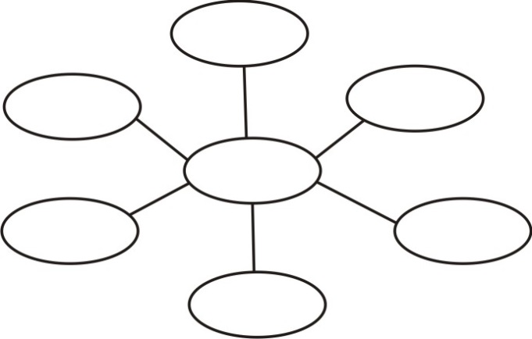
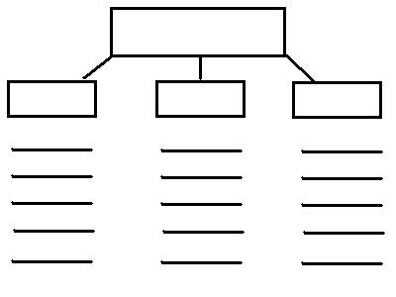
B
A

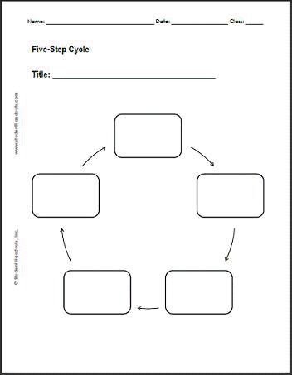
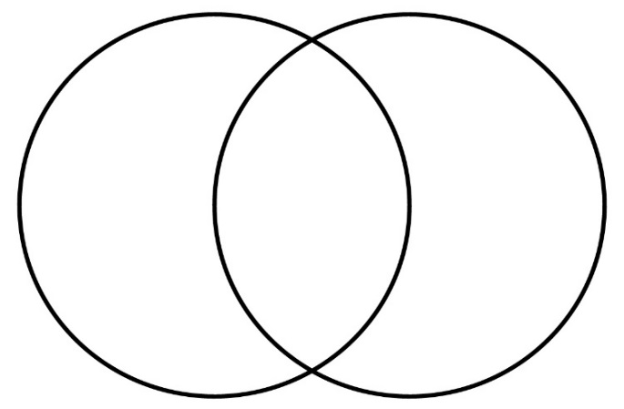
D
C

11.) Out of the above graphic organizers, which one would you be more likely to use when:

_____ listing the different types of human body systems and key characteristics of each?
_____ comparing and contrasting the Reproductive Systems of males and females?
_____ showing how the heart in the Cardiovascular System works?
_____ naming the different parts of the Musculoskeletal System?

12.) How could you choose an appropriate graphic organizer if you are not already familiar with them?

13.) If you formed a study group a few weeks before a test and none of the students heard about graphic organizers before, how would you introduce the group to them? What points would you be certain to address?

14.) Think about a topic that you are currently learning about in one of your Allied Health (or other) courses that you could create a graphic organizer for. Which type of organizer would you choose and why?

Visual Aids:
During quizzes, exams, and even on homework assignments, you will be expected to not only recall important information, but also be able to identify them on a diagram. What is another way that you can organize information and learn it more effectively? Using a visual aid is another helpful tool. A visual aid is some type of illustration or picture that helps us to understand information more easily.

15.) Color and label the following illustration of the Integumentary System below. You are welcome to use any resources, such as your textbook or a reliable website.

16.) How might using a visual aid while you study help increase learning and better prepare you to identify information on a diagram during a test?

In the past, coloring was just thought of as an activity for children. However, recent studies have shown the many benefits it can bring. Coloring allows us to relax, de-stress, and combat anxiety, all of which will be very helpful while studying for a test. Also, coloring allows us to focus on a task and minimize distractions while utilizing our creative side. There are many human body coloring books and online resources available, so make sure to incorporate visual aids in your studies!

Follow-Up:
17.) Are there any learning and study tools that were not mentioned that you have been using successfully? What are they?

18.) How can tools such as graphic organizers and visual aids help you learn and better prepare for tests? How will they be easier to use rather than simply re-reading notes or homework assignments?

19.) Which will you commit to start using immediately, and how will you go about in doing so?

You are well on your way to finding success in AH 60 and all of your classes! To receive credit for completing this assignment, you will participate in an online follow-up session with a Center staff member. Go to the “Follow-up Sessions” tab on the Multidisciplinary Student Success Center Online Supplemental Learning Assistance site: http://www.lbcc.edu/SuccessCenters/mdsc/ to schedule your online appointment with a Center staff member.

THE MDSC IS HERE TO HELP!
There are many learning/study strategies you can utilize, and our LBCC Multidisciplinary Success Centers are here to help. Visit their website to view Study Skills Videos at http://www.lbcc.edu/LAR/studyskills.cfm
or download their Study Skills Handouts at http://www.lbcc.edu/LAR/handouts.cfm

