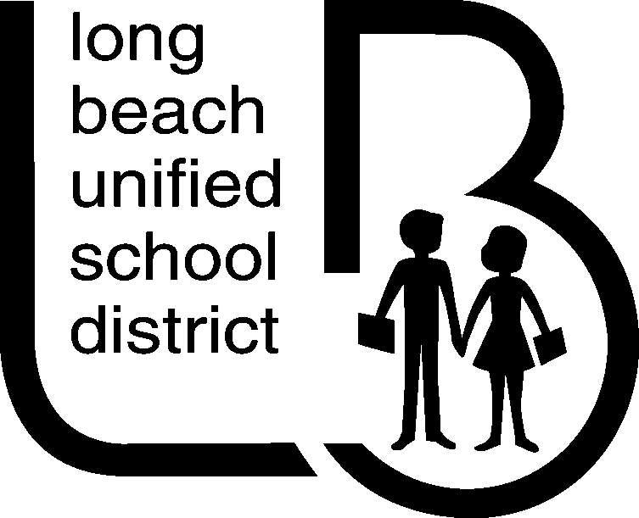
OFFICE OF THE DEPUTY SUPERINTENDENT
Curriculum, Instruction & Professional Development
1515 Hughes Way, Long Beach, CA 90810 ● (562) 997-8267 ● FAX (562) 997-8301

November 2013

Dear Parent or Guardian:

Congratulations! Your student has reached the 12th grade and it is time for them to think about their plans after high school. Long Beach Unified School District has a wonderful opportunity that allows our students to attend Long Beach City College’s Promise Pathways program. The Promise Pathways program allows students to enroll in coursework at Long Beach City College (LBCC), as early as the first semester, to start fulfilling college-level requirements. To help select the appropriate classes, LBCC has requested academic and demographic information, including course grades and STAR test scores, about your student. For those parents/guardians who agree, Long Beach Unified School district will release this information for educational purposes to Long Beach City College.

Long Beach Unified plans on sending the released data to Long Beach City College at the end of the first semester in order to have the most accurate data at the time of registration. Students will need to complete the four step application process to be enrolled in the Promise Pathway program. The four steps are listed on the LBCC website, http://www.lbcc.edu/outreach/. Providing LBCC this high school data may prevent your student from being enrolled in courses that are not college-level (remedial) and, therefore, not transferrable. Enrollment in courses that are not college-level may increase the number of courses and time a student needs to transfer to a four-year university.

While we feel that providing student data to LBCC will be beneficial to our students, we do understand that some families will not feel that it is necessary. If you agree with releasing your student’s course and test information to LBCC, there is nothing more to do. If you do not approve of releasing your student’s information, please complete the “Parent Opt Out for Release of Information” section below and return it to Carol Ortega, Office of the Deputy Superintendent ,1515 Hughes Way, Long Beach, CA, 90810 by December 1st, 2013.

If you have questions about the Promise Pathway program, please visit LBCC’s website, http://www.lbcc.edu/outreach/.

Sincerely,

Christine Dominguez, Deputy Superintendent
Curriculum, Instruction and Professional Development

Parent Opt Out for Release of Information to LBCC

Student Name:____________________________________________Birth date:____________________________

School:__________________________________________________ Student ID#:__________________________

I do not give permission to the Long Beach Unified School District to release my student’s academic and demographic data to Long Beach City College for educational purposes. I understand that if I choose not to consent to the release of data, my student may still participate in the Promise Pathways at Long Beach City College.

Parent/Guardian Name:_____________________________________________________ Date:________________

Parent/Guardian Signature:_______________________________________________________________________

